**Roadmap by Prerit Munjal at Technical Suneja (YT) – Linux (Netstat, dig, up, down etc), Network (Cider ranges, RFC1918 private**

**& public, bridges, how network works & what it does etc) & OS ( PS, aux etc), Cloud (Azure or GCP), Docker & Kubernetes (*most**

**Important, not just deployment, service, ingress, but also what are the best practices to make a Docker File, how is caching**

**Implemented, how is multistage built done etc), CI/CD Tool (Jenkins or GitLab), IAC (Terraform), Projects (1st make a portfolio, do**

**VM Instance, install Apache, put all your code & run it, 2nd project create domain name (with this you understand what are good**

**DNS etc), put it behind load balancer, it will come behind Aneka Stype, it will hit there & according to forwarding rules make a**

**Forwarding rule as a slash comes make a call to other instance, there it will forward to another instance, 3rd project Dockerize the**

**Same project, making its docker file & run it on Kubernetes or any server like Cloud Run, 4th you can introduce CI/CD as well on it**

**Later), also you should know WebDev i.e. Frontend & Backend, don’t just follow courses but also read Documentation, blogs or**

**work in a Company.**

**Roadmap by Paras Thakur at Technical Suneja (YT) – Linux (how IP address assignment is done, how rules are created in Firewall,**

**Networking, Cloud (Google ACE), prepare good LinkedIn Profile (LinkedIn is your Resume today), don’t apply for Job directly,**

**reach out to a person working in the Company in a similar role and ask for referral**

**Top Websites for Remote Devops Jobs (**[**https://www.youtube.com/shorts/MFB8l7Q3-fA**](https://www.youtube.com/shorts/MFB8l7Q3-fA)**)**

**Abhishek Veeramalla :-** (i) Very Strong Foundational Knowledge/ Basics (Eg: knowledge about AWS IAM roles, Kubernetes Architecture etc.

(ii) Practice all the Concepts and have Practical Knowledge (Eg: create all AWS IAM roles and tasks related to it.

(iii) Projects (Eg: CI/CD, EKS)

(iv) Right Resume and preparation of LinkedIn Profile (include the important keywords so that recruiters find you and call you)

**LEC01**

**Prequisites**

1 No Programming required

2 No Linux required

3 No prior IT experience required

4 Non Tech background can also do it

**Why do organisations need Devops Specialists ?**

1. Fast Delivery

2. Higher Quality

3. Cost Effective i.e. Less Capex & Opex (No need to buy own Servers)

4. Less Downtime or Reduced Outages

5. Continuous Feedback

6. Lesser Bugs

**SDLC** : Eg : Preparing any Dish from cutting Vegetables to serving

Develop -> Build -> Test -> Quality Assurance -> Deploy -> Maintenance -> Monitoring

This is the Waterfall model (step by step model)

Terminologies : Onsite, Offshore etc

Technologies Involved in Devops :

Develop **(Github)** -> [**Jenkins]**-> Build (.exe) **(Maven)** -> Test -> Quality Assurance -> Deploy **(Chef/** **Ansible/ Docker/Kubenetes/Puppet)** -> Maintenance -> Monitoring **(Nagios/ Cloudwatch)**

**LEC02**

**Why Devops ?**

There is a Developer’s Team (working on Develop -> Build -> Test -> Quality Assurance) and also there is an Operation’s Team (working on Deploy -> Maintenance -> Monitoring).

The Problem in real world is that many a times the Development Team develops a Software that is working fine at their end but is not working properly at the Operations Team side (i.e. at their server). Some possible reasons can be **(i)** Some supportive software installed at Developers side server but missing at Live Servers, **(ii)** Version of Linux different at Developers side server and Live Servers, etc. Also many a times there are issues (clashes or conflicts) even within the Development Team i.e. between the Developers, Build Team, Testers and QA Team members due to issues in code. All this lead to more time being taken to deliver the Project and showed lack of productivity and automation and moreover had an environment of internal clash. Also, previously all this was done manually.

Also In SDLC, everything for a Project was built and then after the product was complete then only it was showcased to the Client. Meanwhile if some other company had already built the same Product before this Team and launched in the market and it became a success then all the efforts of the first company would be of no use. Secondly, even if they still think of launching their product also in the market with some improvements, they will not be able to change much of the ready product. Also, even if they try to start fresh again then it will take a whole lot of time and issues as discussed in the previous paragraph.

Now with Agile Methodlogy, Client will review the Product every one or two weeks and provide Continuous Feedback to the Developer and Operations Team. In Agile, there is a Scrum Team (consisting of all Developers, Build Team members, Testers, QA Team members and Operation’s Team members) and there is a Scrum Master who takes a Daily ***Sync Up Call/Stand Up Call/Scrum*** ***Meeting*** every morning for around 30 mins. Here, at the starting phase of the Project, generally the Project planning and the tasks distribution among the Team is discussed on this call. Once the working on the Project is started, then every day in the meeting each member is asked to tell what he has done the previous day and what all tasks is he planning to do today and everyone listens to each other. Also, any issues if faced by anyone are discussed here and possible solutions to them are also discussed here

Devops Engineer is the one who understands or is expected to know about everything in SDLC such as Code Building, Code Testing, Quality Assurance, Deployment, Maintenance and Monitoring except Development.

Now with Devops, everything is smooth and automated. There are various tools used to automate every process in the SDLC such as below :

Develop **(Github)** ->**[Jenkins]**-> Build (.exe) **(Maven)** -> Test -> Quality Assurance -> Deploy **(Chef/** **Ansible/ Docker/Kubenetes/Puppet)** -> Maintenance -> Monitoring **(Nagios/ Cloudwatch)**

These are all general Technologies which are mostly open-source and can be used with any project or environment as they are not dependent on any cloud provider.

Also, there are specific tools provided by every cloud provider to perform and automate the various SDLC processes. For eg: AWS Devops provides tools such as Codecommit, Codedeploy, Codepipeline etc, Azure Devops provides tools such as Azure Repos, Artifacts etc.

**Devops** – Implementing automation at each and every step

**Devops Stages** – ***(i) Version Control*** – Maintains different versions of the code as and when updated. This is done at Developer level and tool used is Git.

***(ii) Continuous Integration*** – Compile, validate, Code Review, Unit Testing, Integration Testing. Tool used is Jenkins.

***(ii) Continuous Delivery*** – Deploying the build app to test Servers. Tool used is Maven.

***(iv) Continuous Deployment*** – Deploying the test app on the Production Servers for Release. Tool used is Chef, Ansible etc.

***(v) Continuous Monitoring –*** Continuously Monitoring the Live app at the Production Servers

**Devops** is a combination of two words i.e. Development and Operations. Devopsis a methodology that allows a Single Team to manage the entire Application Development Life Cycle i.e. Development, Testing, Deployment and Operations.

The objective of Devopsis to shorten the System’s Development Life Cycle.

Devopsis a Software Development approach through which superior quality code can be developed quickly and with more Reliability.

**# Improvements in SDLC :** Waterfall Methodology(step by Step) -> Agile Methodology(entire work distributed into Sprints)(works only at Development level) -> Devops (improvement of Agile Methodology)(works at both Development and Operations level)

**Devops Infinity Logo:** Plan ->Code -> Build -> Test -> Release(Integrate) -> Deploy -> Operate -> Monitor

**LEC03**

Any IT Organisation who wants to make an application, needs a lot of servers to run and process the Business Logic and to store Data. A ***Server*** as the name suggests is a device that is used to provide a service. A Server can be used to serve thousands of users at a time providing processing and storage services.

Eg – For a small company, we need 50 servers. Cost of 1 server is 1 to 5 lakh. So, Capital Expenditure will be Servers Cost + Liscense Cost (for using various Softwares : Windows, Antivirus, Firewall) + Networking (Router, Switch, Gateway, Cabling) + A.C. + Employees Cost + Maintenance Cost = 2 Crores Approx . Also, if setting up a Server completely takes 10 days by 1 person, then 50 Servers will be set up in 10 days by 50 people. Further the Product will be developed over a period of 1 year with an average cost of 50 lakhs spent over that year. So, here the Cost & Time consumption is very huge just to create our Product and still there is no guarantee that the Product will be successful or not i.e. Returns Over Investment not guaranteed.

Here, **Public Cloud Providers** like AWS (market leader/ first mover) came up into the market with Rental Services Model where they will provide all the above discussed services at nominal charges on monthly basis to the Customers and Organizations. Here not only the Cost but the Time is also greatly reduced. In Cloud setting up 50 Servers completely takes not more than 5 mins. All this is referred to as Infrastructure Services provided by Cloud.

Cloud provide 3 Services IaaS (Infrastructure as a Service), PaaS (Platform) and SaaS (Software).

**AWS Cloud** – It has 24 Regions, 76 Availability Zones

Regions are places all over the World where AWS has created/established its Data Centers.

These Data Centers are actually created in their Availability Zones and are known by their Availability Zone’s name. There are minimum 2 AZs and maximum 6 AZs in one Region.

**What is a Cloud ?**

Whatever we are accessing through the **Internet**, we are using Cloud behind the process as the data is already stored on a server and we are accessing it through internet. So, one important fact is that we cannot use cloud technology without internet services. So, cloud is the technology which provides the ability to share your resources from a remote location. Cloud is not a server or storage but is a service which provides us resources, which we can use from a remote location and we can pay according to the usage.

**Creating AWS Free Tier Account**

1. Goto <https://aws.amazon.com/free>.
2. Select “Create a Free Account”
3. Enter your email ID and Name and verify your email ID
4. Enter your Address Details, PAN and Credit/Debit Card details
5. Complete email verification and Card Payment of Rs.2
6. Once confirmed you will receive an email, then sign in and start your Cloud journey with the AWS Free Tier Account

So, here we can create server from any region (visible at top right corner of page).

**Some important key points to note:**

1. Always remember the region where you have created your server so that you remember it when you have to delete it. Always work in a single region.
2. Every time after logging in, firstly check your Billing Dashboard. If there is any Billing Amount then go to “Billing Details” and check where the charges have been applied. If you had left any server running at any location then go and delete it. Still, if your bill has been generated due to any reason then goto “Support Center” and click on “Create Case”. Click “Account and Billing Support”, Type – “Billing”, Category – “Dispute a Charge”, Subject – “Request for waive off for my bill”, Description – “I am a student, I don’t have money and I am using this account for learning purpose, so please waive off for my bill”, select Contact Method – “Phone”, then oyu can explain over call.

**Creating a Server** **(Creating a Linux Instance using Amazon EC2 for free)**

Go to Services -> Compute -> EC2 -> Select “Running Instances -> Launch Instance -> Select “Amazon Linux 2 AMI and click “Select” button -> Select the green “Free tier eligible” written version **(Use this server only as and when needed as it has limited hrs free usage)** -> click “Next: Configure Instance Details” -> Number of Instances – Mention “1” **(Here you can enter any number let say 1000 and then instantly within next 3-4 mins AWS will create 1000 servers for you)** -> Let all the other have the default selected options -> click “Next: Add Storage” -> click “Next: Add Tags” -> enter Key – “Name” and Value – “Linux Server” (The purpose of tag is to use it later to search by the name) -> click “Next: Configure Security Cloud -> Here for Linux Server the Type should be “SSH” and Source – “Anywhere” -> click “Review and Launch” -> click “Launch” -> Choose “Create a new key pair” and provide Key Pair Name – “Linux123” -> click “Download Key Pair” -> click “Launch Instance” -> click “View Instances”

Now, under Status Checks, if it shows “2/2 checks”, it means our server is ready

**Installing and setting Putty** (Most popular way to access Linux)

1. Search Google for “puttygen and putty”
2. Here inside “[www.puttygen.com](http://www.puttygen.com)”, download “putty.exe” (the SSH and Telnet Client)(64 bit) and download “puttygen.exe” (a RSA and DSA key) (64 bit)
3. Now at bottom of the screen, click a screen icon and there copy the IPv4 Public IP address
4. Open Puttygen -> click “Load” -> open your key “Linux123” (generated above in EC2) -> after Successful message click OK -> click “Save Private Key” and Yes -> Save in Desktop and give name “linuxkey “ -> close Puttygen. You can see linux key generated with .ppk extension

**LEC04:-**  **Basics and History of Linux**

Linux is an Open Source tool (i.e. its code is Open Source),

* Not a clone of Unix,
* Secure,
* Fast
* Linux is a Kernal
* Actually Linux (i.e. a Kernal) + GNU(i.e. Softwares) -> O.S.
* Companies commercially providing Linux are RHEL (Red Hat Enterprise Linux), Fedora Group, Debian, Others (Ubuntu, CentOS (Community Enterprise O.S.), Amazon Linux, Kali Linux etc) etc
* CentOS is fastest among all
* Ubuntu is 3rd largest OS used in the world

O.S. can be used by 2 ways i.e. CLI or GUI. Windows is the most popular GUI & Linux is the most popular CLI. Linux also has GUI but it is not so popular.

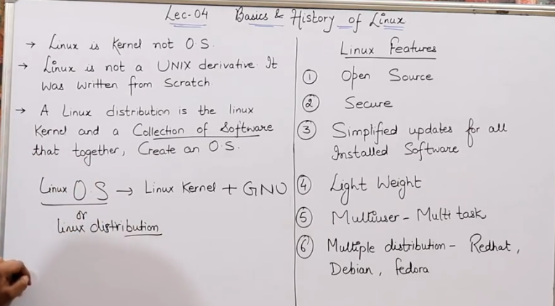

Linux based OS is more popular & widely used in Corporate Companies as compared to Windows based OS as **Linux is free** to use by anyone whereas to use Windows OS they will have to buy Licenses which will incur huge costs. Also, **Linux is more secure** and does not require antivirus while Windows require antivirus. Also, if by any chance virus enters into Linux then it only resides inside that particular folder and not the entire system and can be removed by deleting the file but in case of Windows virus gets spread from a folder to the entire system and if it does not get removed by the Antivirus then windows will need to be re-installed and uninstalling the previous version. (Windows own free Antivirus is MRT)

**Lightweight** means RAM consumption is less.

**Multiuser** – In Linux multiple users (there is no upper limit)can work using different Terminals on a single shared CPU & Storage

**LEC05:- Basics and History of Linux**

Diff. b/w Windows & Linux Architecture –

* In Windows, O.S. interacts with the Hardware whereas In Linux, Kernel interacts with the Hardware. In both cases, User interacts with the Shell.

# In Windows, when we use the GUI using the mouse & keyboard, in the backend the commands run in the Command Prompt on behalf of the user.

* Linux is fast as it directly uses Command Line. In Windows, additional GUI layer is there so it is comparatively slow.

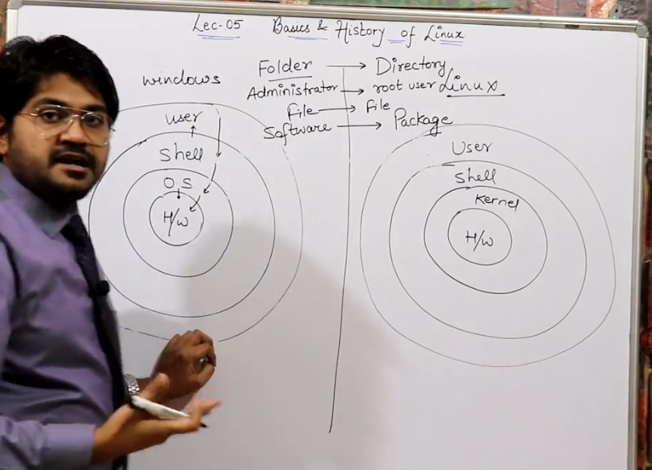

File System Hierarchy

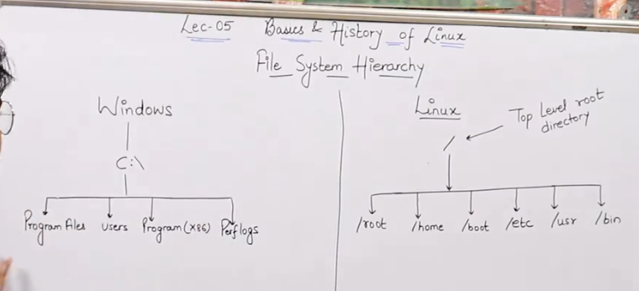

Whenever you install windows on your system, by default C drive is created. Other drives get created only if we do the partition of the hard disc. All the configuration files and files related to Windows are present in the C drive. In Linux, instead of C drive there is a top level root directory i.e. folder, denoted by “/” (forward slash). Linux follows the **tree structure**. In C drive we can see default folders such as Program Files, User, Programs(X86), Perflogs etc. Similarly in Linux there are also some by default directories which get created while installing Linux inside the root directory. We will discuss about some important directories.

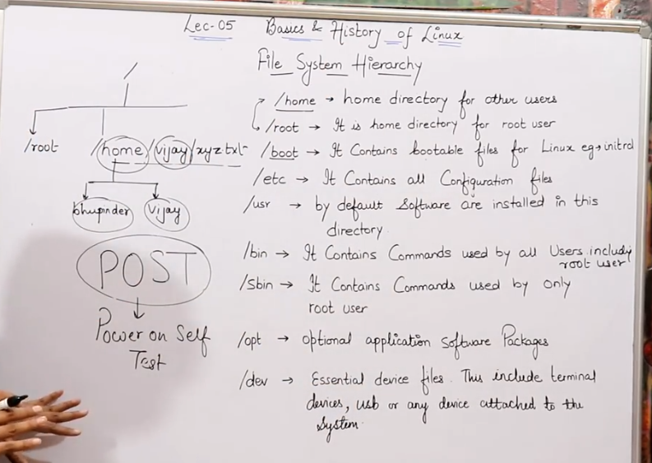

Whenever we login into Linux, we can either login as an **administrator** also known as the **root** **user**. If we have created any other users then we can login as a **home user**, except the root user. **Booting** means the operating system files are getting activated and it also checks if all hardware devices and Systems are working fine (such as is battery charged etc ?, is hard disk connected ?, is RAM available ?, is power turned on ? etc). **Configuration** files are basically hardware details such as RAM size, hard disc size, processor version. **Sbin** means system binary. **/dev** contains files which are used to connect peripheral devices such as Mouse, printer, external hard disc etc.

**LEC06:- Linux Commands And it's use cases *(Remember, Linux is case-sensitive)***

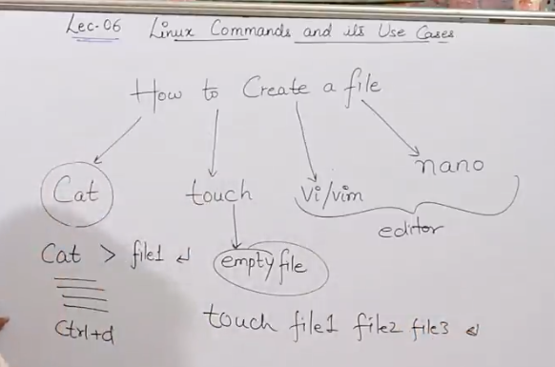

Linux Commands for creating a File:-

1. cat - cat > file1 (enter)

After this the cursor will enter into the new line. Now you can write the content in your file. Now to save your content write Ctrl+D, then you will come out of the file and your content will be saved. The limitation of cat is that you cannot edit the file using this command.

1. touch - Touch command is used to create an empty file.

Also used to create multiple empty files. Example : write command "touch file1 file2 file3" (enter), it will create multiple empty files.

1. vi/vim - Used to create and edit files.
2. nano - Used to create and edit files.

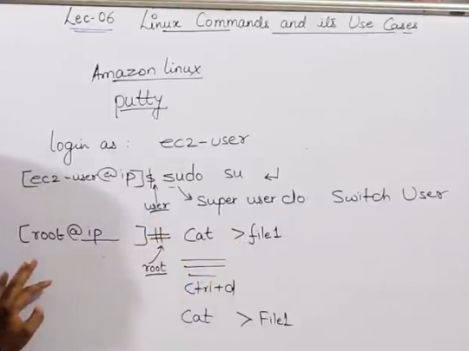

**Sudo su** // it will switch ec2 user to root user

**Linux is case-sensitive. So** cat > file1 & cat > File1 will create two new files file1 & File1.

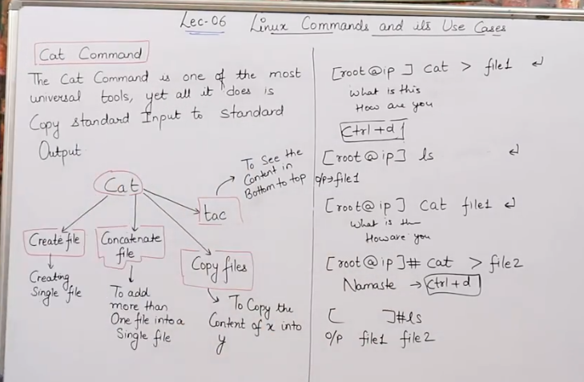

**ls** //lists down the contents of the directory or the file

**/cat** – Derived from ‘Concatenation’, can be used to (i)create a file, (ii) concatenate multiple files, (iii)view file, (iv)tac . It cannot modify a file.

Here “>” means redirecting output. So, cat > file1 is used to create a new file and cat file1 is used to open the file.

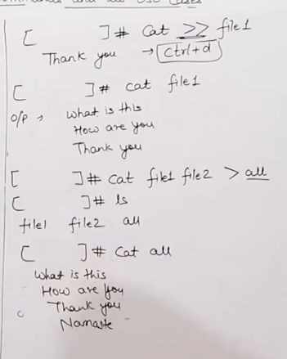

To add something to existing file we use “>>”. Here In the picture above, all is a concatenated file.

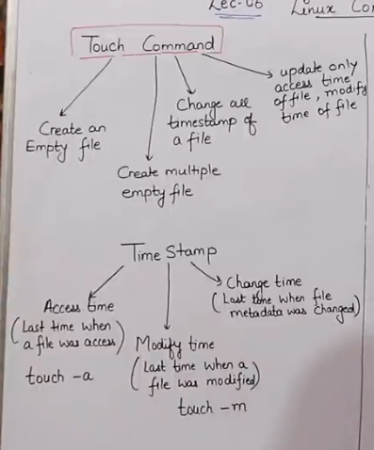

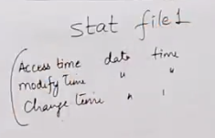

Stat command is used to see the time stamps i.e access time, modify time and change time. It is also used to change all time stamps at once.

To change all time stamps at once :-

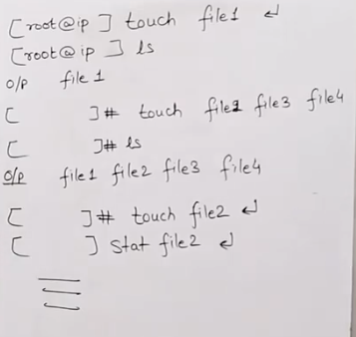

To change one time stamp at a time:-

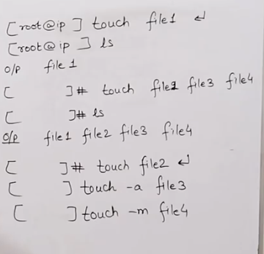

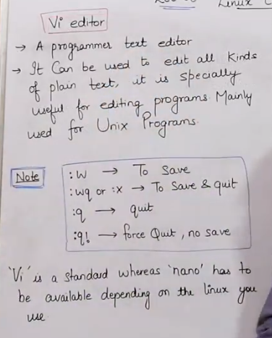

Vi is more powerful editor as compared to Nano but Nano is easier to work with as compared to Vi. Vi command works on every version of Linux whereas Nano might not work in every version of Linux.

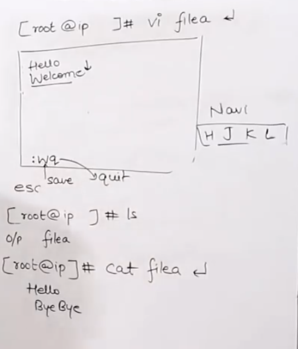

Here, correct Output is : Hello (nextline)Welcome

In vi editor : vi filea (enter)  // it will create a new file

Then, press i to enter the editor to insert your text. Write data in your file. To save it and come out of the text editor, press escape and enter :wq which means save and quit. Now, to view this file use cat command. To navigate inside the Vi text editor we can use the keys H, J, K, L or the arrow keys.

Nano Command :-

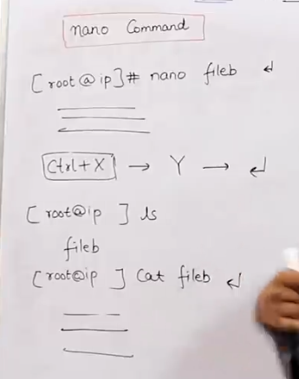

After entering nano fileb, nano editor will open and we can directly enter the text. To escape enter Ctrl+X, then it will ask to save, enter Y and then enter (it will save and come out).

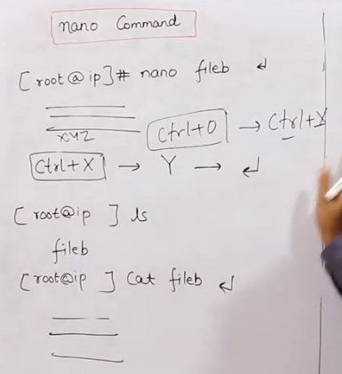

To update your file, open the file, update your changes and then enter Ctrl+O to overwrite the data and then enter Ctrl+X and continue.

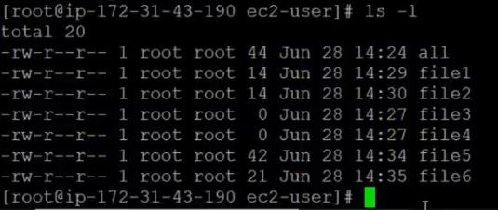

**ls -l or ll** // This command is used to get the list of all the files and their details. Here -l is **long list**

Here in the list details , if the details start with **“d”** then it means it is a **directory** and if it starts with **“–“** then it means it is a **file**

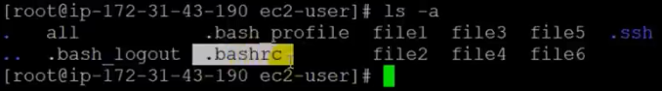

**ls -a** // This command is used to get the list of all the files including the hidden files (starting with .)

**ls -al or ls -la** // This command is used to get the long list of all the files including the hidden files

**history** // This command is used to get the list of all the commands used in that day or session.

**Linux part 4 -**

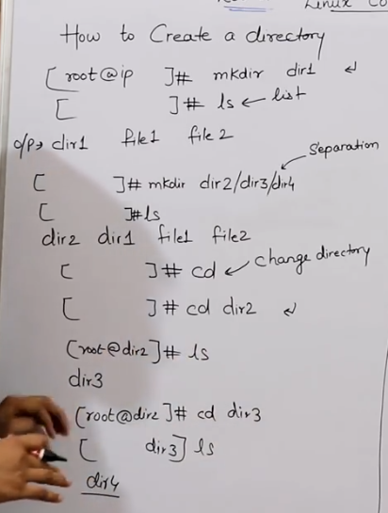

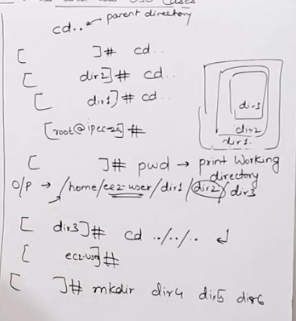

mkdir -p dir1/dir2/dir3 // to make a directory inside a directory

Hidden files are default windows files which are very important files. They are kept hidden so that they do not get deleted by mistake by anyone. Hidden files donot have any relation with security or virus prevention, they are hidden just to make them safe.

For creating hidden file and directory. We can create a hidden file using any method cat, touch, vi or nano using . before the file.

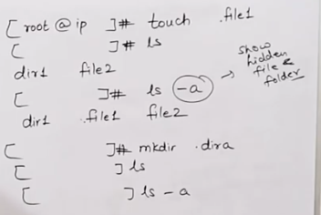

To copy, cut/move or rename a file.

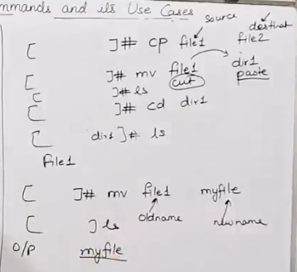

To remove Or delete a file Or directory

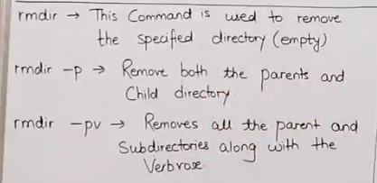

The rmdir command is used to remove empty directories in Linux. It has the following syntax:

rmdir [options] directory

Some of the common options are:

* -p or --parents: This option removes the directory and its ancestors. For example, rmdir -p a/b/c will remove the directories a/b/c, a/b, and a if they are empty.
* -v or --verbose: This option prints a message for each directory that is removed.
* --ignore-fail-on-non-empty: This option ignores the errors when trying to remove non-empty directories.

If you want to remove a directory that is not empty, you can use the rm command with the -r or --recursive option. For example, rm -r directory will remove the directory and all its contents.

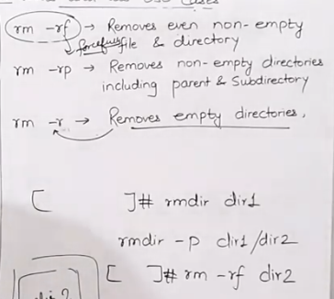

rm -rf * //used to remove all the files from that folder/location

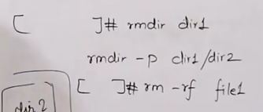

* less file5 // used to show the content of the first page of a file
* more file5 //used to show the content of all the pages of a file
* head file5 //used to show data for first 10 lines of a file
* tail file5 //used to show data for last 10 lines of a file
* Press q to exit from less or more

**Linux part 5 -**

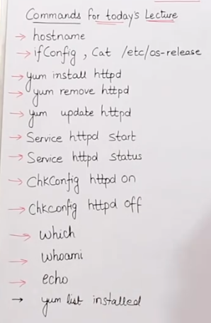

hostname are the details of the machine

ifconfig // used to check the ip address, ethernet, ports, network cards etc of the Linux machine,

hostname -i // to get only IP address details

cat /etc/os-release // to get the version and other details of your Operating system

cat /etc/os-rel* OR cat /etc/*rel* // Here Linux will auto complete the command to get the version and other details of your Operating system

Full form of yum - yellowdog updater modified

yum is a package used to install, uninstall, remove, upgrade or downgrade a software or a package. yum package is by default installed in Linux

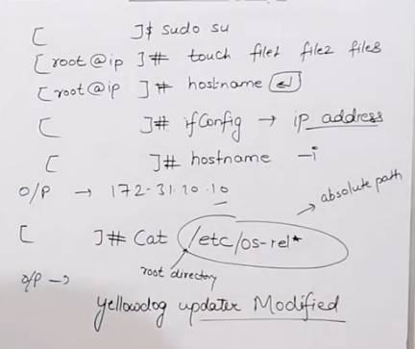

httpd is used to install Apache server by default in Linux

(Examples of yum:- yum install httpd –y; yum update httpd –y; yum remove httpd –y)

-y // command is used to input yes as the answer every time when Linux asks for yes or no

Yum list install // to get the list of all the packages/softwares already installed on the machine

service httpd start // used to start or active the software i.e. httpd if httpd is already installed

service httpd stop // used to stop httpd

service httpd status // used to check the status if httpd is active or inactive

chkconfig httpd on // used to start the software(httpd) automatically whenever a server restarts after a shut down

chkconfig httpd off // used to stop the httpd

which chef | which tree | which Ubuntu | which git // used to check if a software is installed or not

whoami // shows which user I am i.e. root user or normal user

echo “hello” // used to show an output on a screen or print a command from a script

echo is also used to create a new file using > and update the file using >>

(Eg :- echo “hello” >testfile // to create a new file

echo “welcome” >>testfile //to add data to existing file

echo >filez // used to empty a file

grep Bhupinder etc/password // used to get a particular word eg 'Bhupinder' wherever present inside a file named password

It is similar to find functionality or ctrl + f in windows

sort // used to sort data alphabetically inside a file

tree // used to see the entire directory structure

( Tree is not already installed inside Linux, so we have to install it using :- yum install tree –y )

Ctrl+L // To clear the screen

**Linux lec6 -**

Ss 4:53

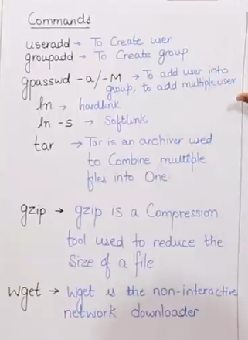

Ss 12:00

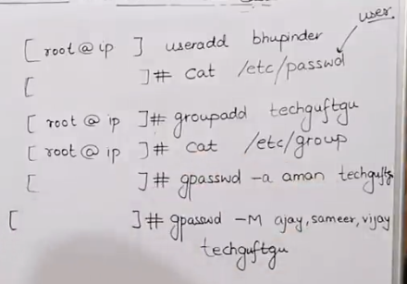

In a system, we have administrator or root user by default. We can also create other users using “useradd” command. We can also create a group for users using “groupadd” command.

Here, a user ‘bhupinder’ has been created and can be seen inside /etc/passwd. Similarly, group ‘techguftgu’ has been created and can be seen inside /etc/group. ‘bhupinder’ can also be seen inside the group folder because if a group is not created for the user then the user automatically creates a default group.

If we want to add a user to a group, we use “gpasswd -a user_name group_name”(syntax) (-M for multiple users)

We can create a link for a file using ln. Link is like an exact copy of a file at some other location and it gets updated as and when the original file gets updated.

Soft link is a shortcut created for the the file or link created.

Eg1:- ln -s file1 softlinkfile1 // file1 is original file & softlinkfile1 is Soft link

The **long list** for a Soft link starts with ‘l’ which indicates it is a link (like ‘d’ for directory & ‘-‘ for file)

If some data is added to softlinkfile1 then it will automatically get added to file1.

If file1 gets deleted then softlinkfile1 will still show(in red) but will not be accessible anymore.

Eg2:- ln file2 hardlink2 // file1 is original file & hardlink2 is Hard link file

The long list for a Hard link starts with ‘-’ which indicates it is a file.

If some data is added to hardlink2, then it will automatically get added to file2.

Also, If some data is added to file2, then it will automatically get added to hardlink2.

Here, If file2 gets deleted, still the hardlink2 will be there and accessible.

Gzip is used to compress individual files.

Tar is used to combine numerous files and directories into a single archive file (it retains the original files and directories). It does not compress the files.

Ss 25:29

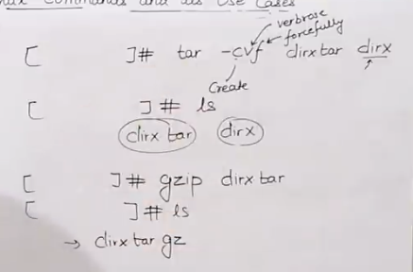

The long list for a tar file link starts with ‘-’ which indicates it is a file (similar to zip file).

Ss 28:45

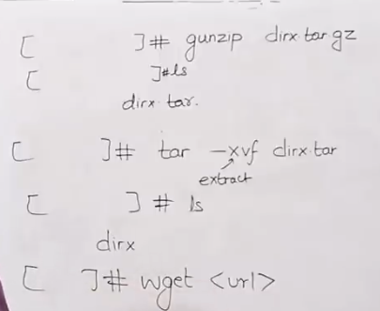

wget is used to download a file or software from a browser into the Linux machine. This command works i.e. downloading is in progress even if a user is not active or not logged-in. Also, it re-tries automatically several times to download a file if the network is down.

Lec 7

Ss 1:22

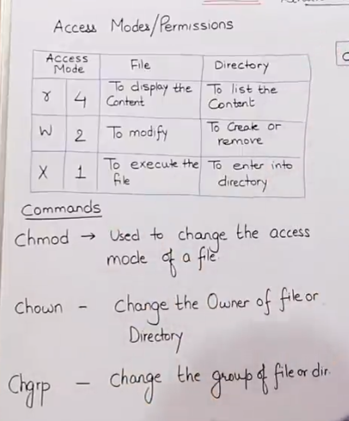

The files which do not open but get executed on clicking are called executable files. Eg. Chrome.exe file

If a person has all the three permissions - read, write and execute, then he can delete, modify and run the files.

A group by default has read and execute permission

Any other user by default has only read permission

Ss 9:14

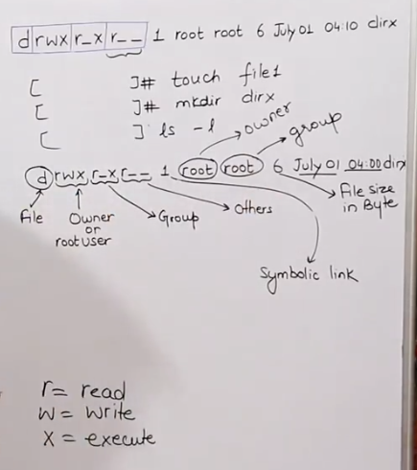

Symbolic link refers to the number of links a file or directory has.

Ss 14:23

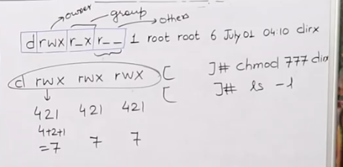

Ss 16:19

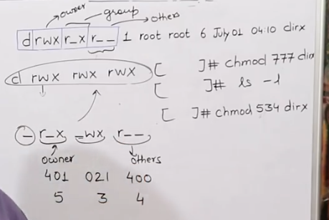

Ss 18:03

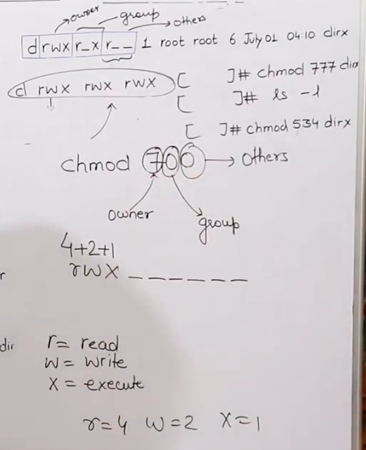

Ss 19:11

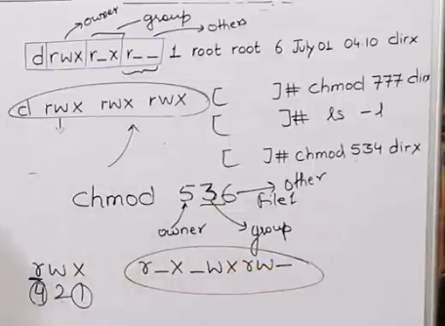

Ss 22:40

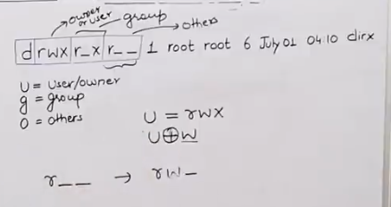

Ss 23:18

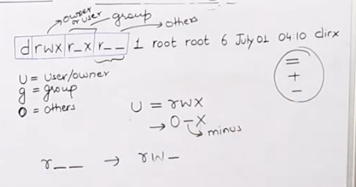

Ss 24:16

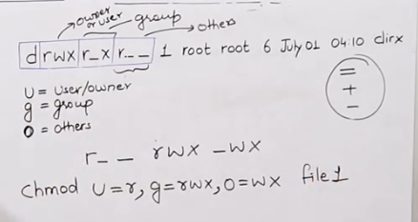

Ss 25:16

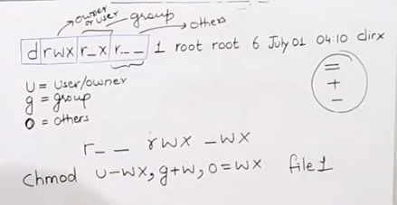

Ss 27:42

